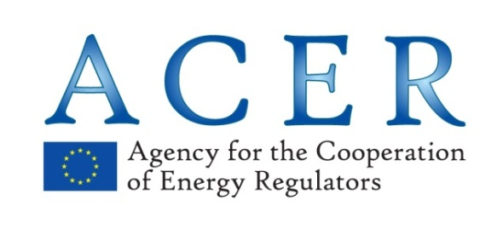

PRIVACY STATEMENT ON: Flexitime

The Agency for the Cooperation of Energy Regulators (the ‘Agency’) processes the personal data of staff in line with Regulation (EC) N° 45/2001 of the European Parliament and of the Council of 18 December 2000 on the protection of individuals with regard to the processing of personal data by the Community institutions and bodies and on the free movement of such data.

Identity of the controller in practice
Head of the Administration Department of the Agency for the Cooperation of Energy Regulators.

Purpose of processing
- Time recording
- Recuperating accumulated excess hours under certain conditions

Lawfulness of the processing operation
In line with Article 5(a) of Regulation 45/2001, the processing is necessary for the performance of a task carried out in the public interest and for the exercise of the Agency tasks on the basis of Commission Decision C(2014) 2502 laying down the rules on working time and time recording.
Recipients of the data processed
- Human Resources Section (more specifically staff in charge of flexitime and leave management);
- IT Section (more specifically staff managing the leave tool);
- Hierarchical supervisor of the data subject;

Categories of data collected and processed
- Name, surname and the associating department of person concerned;
- Time credits/debits;
- Decision of hierarchical supervisor.

Date when processing starts
Date when the agent starts recording his/her working hours.
Date when the seconded national expert starts recording his/her working hours.

Data storage and data retention policy
Data is stored in SharePoint database and is retained for period of 2 years

What are your rights as a data subject?

You may request clarification on your rights and structure of leave entitlements.
You may request that your leave record is deleted following request to HR section, if such needs arises and is supported.
Data subject has the right and possibility to access information at any time through the HR portal.

Controller in practice

Ms Olga Borissova, Head of Administration
Administration Department
Postal address:
Agency for the Cooperation of Energy Regulators (ACER)
Trg republike 3
1000 – Ljubljana
Slovenia
E-mail: HR-info@acer.europa.eu

Ms Kate Bousfield-Paris, Data Protection Officer
Postal address:
Agency for the Cooperation of Energy Regulators (ACER)
Trg republike 3
1000 – Ljubljana
Slovenia
E-mail: DPO@acer.europa.eu

European Data Protection Supervisor

Mr. Giovanni Buttarelli, Supervisor
Mr. Wojciech Wiewiórowski, Assistant Supervisor

Rue Wiertz, 60
B-1047 Brussels, Belgium
Tel: (+32) 2 283 1900
Fax: (+32) 2 283 1950
E-mail: edps@edps.europa.eu
Website: http://www.edps.europa.eu/

